Prescribing Tip No. 313 Date: 18th March 2021

Updated Guidance on Choice of Blood Glucose Testing Meters and Strips on Sharepoint

Prescribing tip for information

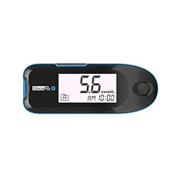
The Medicines Optimisation team have recently worked together with local diabetes specialists to update local guidance on the choice of blood glucose monitoring meters and test strips. The updated guidance can now be accessed via SharePoint. The guidance includes a range of blood glucose testing meters which:

- Meet current ISO standards;
- Possess a range of clinical features and highlights those patient groups for whom they are considered most suitable;
- Are compatible with cost effective testing strips.

NB. Requests for meters and testing strips outside of this guidance should be at the request of the Specialist Diabetes team only and where an individual patient need has been identified. Meters should be provided free of charge from GP surgeries or diabetes clinics. Patients should be dissuaded from buying their own meter – the prescribing of strips and lancets for patients’ own-purchased meters is not supported by the CCG.

The guidance has been updated and also includes recommendations on
- Blood glucose testing strip requirements for patients prescribed Freestyle Libre and/or insulin pump devices.

- Cost effective choices of pen needles for patients prescribed pre-filled and reusable insulin pens.

- Cost effective choices of safety lancets, syringes and needles.

To contact the Medicines Optimisation Team please phone 01772 214302

